Rouge Construction Network Infrastructure Proposal
College of Science, Engineering, and Technology, Grand Canyon University
ITT-116- Platforms and Network Technologies
Instructor Joel
Liela Pressley
08/08/2022
Rouge Construction Network Infrastructure Proposal
- INFRASTRUCTURE AND TECHNOLOGY RECOMMENDATIONS:
Rouge Construction is a company with hopes to expand state-wide with various branches and offices that require network accommodations that are secure and reliable. As seen in the diagram provided, the foundational infrastructure is a wireless mesh network topology with various subnets, VLANs, and WANs branching off of the main routers. Since different office and department handle different types of data and must meet different needs of employees each infrastructure is slightly different. The mesh topology accommodates the company’s medium size while allowing collaboration, scalability, ensured data security and backup technology. This structure will also be reliable, provide speed and performance for clients on the network. Some technology requirements that need to implemented within the mesh network include a level 4 DMZ design that llows for firewall stacking within business services. Four firewalls will be installed with the modem, in the router for the Customer Service/Data network, and in the two routers responsible for Administration.
- NETWORK TOPOLOGY DIAGRAM:
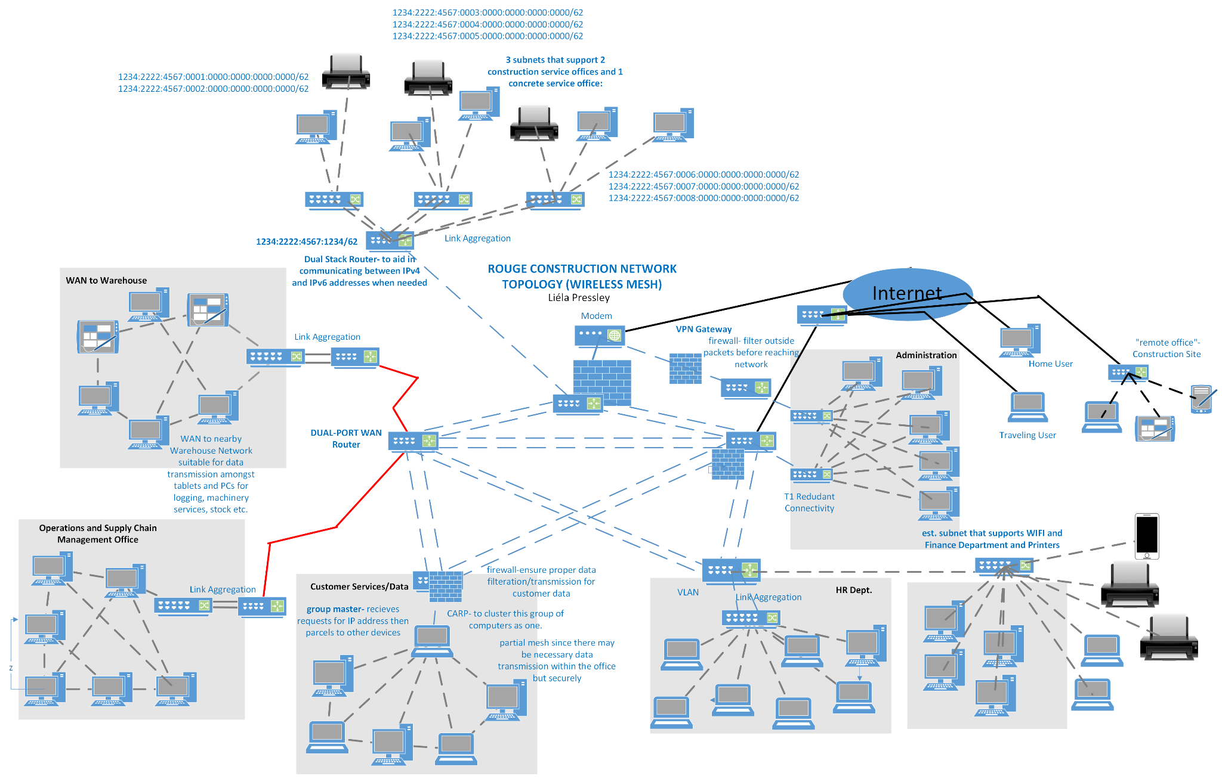
- FINAL CONFIGURATIONS (SWITCHES/ROUTERS):
In total, there are eleven routers and nine switches. The foundational mesh infrastructure consists of five routers that are interconnected, one of which is a Dual-Port WAN Router which allows for WAN services to two different branch offices and another that supports a VLAN and subnet net for the HR/Finance Departments. One router stems directly from the modem to establish a T1 Redudant connection in relationship with one of the main five for the Adminstration Department. There is a dual-stack router that is configured with both IPv4 and IPv6 addresses on its interface to allow for easier traffic flow between clients/traffic of both types on a the Construction/Concrete Services IPv6 network. There are six router and switch connections that have a link aggregation configuration, two that are responsible for T1 Connectivity, two that work together to establish a off-sit VPN gateway and one that supports a subnet for the Finance Department.
- COST ANALYSIS:
The estimated total cost for equipment which includes routers, switches, firewall installation, and the modem (cables not included) is approximately $5,940. The cost breakdown is about $2,200 for all 11 routers, $1,440 for all switches, $2,000 for firewall installation, and $300 for the modem. The estimated for installation is based on the average rate of $1,500 for one office network. Since there are about 7-8 office networks, the approximate total installation cost may be around 9,000-12,000 depending on the company.
- RISK ANALYSIS/RECOMMENDATIONS:
The topology for Rouge Construction was designed with security and performance of data transmission in mind. In choosing to segment the networks into multiple LANs, subnets and VLANs is a basic and necessary implementation to aid network security. In addition to those foundational structures, there are redundancy efforts to ensure that risk levels are lowered as much as financially responsible. The main fault tolerant elements within this infrastructure include T1 redundant connectivity, common address redundancy protocol and link aggregation between switch/routers. These implementations add a layer of protection from single point failure in case of an power outage, or fault somewhere within the network.
When confronting network security risks the company needs to be proactive in transmission and communication security between devices. On a local level, company administrators should include safety tips and guidelines for usernames and passwords. Social engineering and accidental employee error are two of the most common reasons for malicious attacks successfully taking advantage of vulnerabilities within the network. Educating employees on the different social engineering attack techniques from phishing to tailgating, can prevent many potential attacks. When writing and implementing security policies that administration and authorized staff need to prioritize, the prevention of accidental or intentional damages to hardware/software, communicate employee responsibilities with respecting the systems, the protection of sensitive date from unauthorized access etc. Encryption and authentication are two key components of network security. One example of many includes EAP-TLS. This TLS encryption protocol that protects communications using a public key infrastructure to mutually authenticate both the server and suppliant. The most common and heavily recommended encryption protocols include Wi-Fi Protected Access (WPA), WPA2, and WPA3 which encrypt between wireless routers and devices, WPA3 being the strongest.

